DRC Monitoring Protocol

April, 2021

Prepared by: Rica Fulton, Restoration Coordinator, RiversEdge West

# Introduction:

The Desert Rivers Collaborative (DRC) was formed in 2012 to collectively address the proliferation of invasive vegetation species along the Colorado and Gunnison Rivers and their tributaries in Mesa and Delta County. The DRC serves as a platform to work together, share resources, and address riparian health at a watershed-scale. The DRC connects different land owners and land managers and works across boundaries to create efficiencies, share best-practices, and cultivate relationships focused around riparian and river health. Restoration work including initial tamarisk and Russian olive (TRO) removal, TRO re-treatments, secondary weed treatments, and active revegetation has occurred on almost 3,000 acres since 2012 in the DRC area. The DRC utilizes a comprehensive [Implementation Plan](https://riversedgewest.org/sites/default/files/files/2015_06_03_DRC_Plan_Final_V1.pdf) to guide restoration work.

Vegetation monitoring on restoration sites is a critical step in understanding the ecological condition of a site pre-and-post restoration activities. However, monitoring has been inconsistent on DRC sites given funding and capacity limitations, the patchwork of landownership where restoration work has occurred, and other barriers. Some sites were last monitored in 2018. RiversEdge West (REW) currently has procured grant funding from Colorado Water Conservation Board (CWCB) to define and implement the following monitoring protocol for 2 seasons in the DRC area with consultation with interested partners.

The outcomes of this monitoring program and information include quantifiable data to inform the status of restoration sites that have been treated in the past, inform subsequent maintenance and restoration actions on a site-by-site-basis, begin to quantify riparian health at a sub-watershed scale, and engage young adults, community members, DRC partners, and others in stewardship activities in the DRC area.

# Monitoring Objectives:

* Determine implementation and maintenance needs for the upcoming season;
* Track progress/success towards land manager site-specific restoration goals by tracking consistent metrics over time using the same protocol and data collection intervals;
* Inventory and track invasive weed infestations of concern for rapid detection and treatment;
* Track progress towards watershed wide restoration; and
* Formally evaluate restoration method effectiveness and inform adaptive management;
* Inform progress reports and other grantor deliverables.

# Monitoring products

* Rapid Assessments
* Invasive Species Inventory
* Passive Revegetation Recruitment
* Photo Points

# monitoring Sites

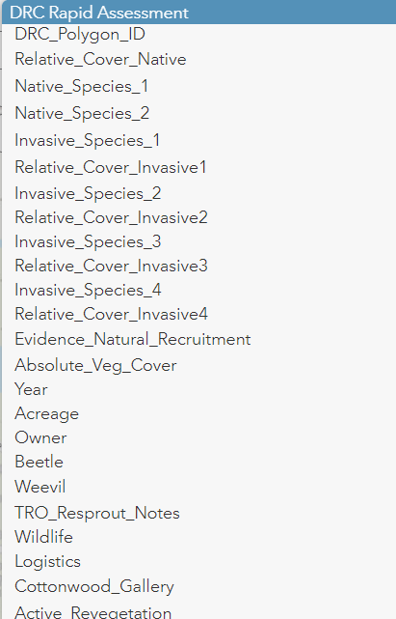Each site will be spilt into different monitoring polygons based on past treatment areas, planned treatment areas, or otherwise based on landowner and land manager input. No polygon will be larger than 20 acres, and ideally smaller than 10 acres. Monitors will conduct a separate Rapid Assessment, Invasive Species Inventory, Natural Recruitment Assessment, and acquire Photo points for each separate polygon within each site. See a list of sites and polygons on page 8.

## RAPID ASSESSMENT

Rapid assessments include ocular estimates of relative cover of native species as a whole within each polygon. This assessment includes both woody and herbaceous species. Additionally, the protocol quantifies the relative cover of the top two native species and the top four invasive species. See the list of common species in sub-section B. Relative cover is defined as the proportion of native vegetation on site in comparison to the total vegetation cover including woody and herbaceous species. For example, all of the vegetation on site is 100%, and 50% may be invasive and 50% native, therefore, the relative cover of native species would be 50%.

Figure 1. Rapid Assessment data sheet

This assessment also includes an estimate of absolute vegetation cover, which is defined as the total vertical projection area of live native and non-native vegetation on site compared to bare-ground. For example, a polygon may be 3 acres with 45% of the ground covered with live vegetation and the other 55% bare ground or otherwise.

Additional attributes that are collected in the Rapid Assessment include the year, person monitoring, acreage, land ownership, if a site has received active revegetation, presence or absence of the tamarisk beetle or weevil, notes on tamarisk and Russian olive re-sprouts, any signs of wildlife, and any relevant notes regarding site access or logistics.

1. Procedure:

The two-person monitoring team will walk the entire polygon making ocular estimates, and before filling in the attribute fields (see list of attributes below) they will discuss their conclusions. While they are walking the site, they can conduct invasive species inventory as they come across infestations (see Invasive Species Inventory in the next section.) Sites are predetermined by the land manager, land owner or DRC coordinator, and are ideally less than 20 acres in size. Data is recorded with Arc Collector or Arc Field Maps on tablets. Monitors sync data to Arc Online from the downloaded offline maps on their tablets.

1. Monitor site criteria:
   * Actively treated;
   * Active treatments are scheduled;
   * Special sites via land manager request.

* Attributes:
  + DRC Site ID and Polygon ID
  + Relative native cover - pre-determined intervals, e.g., 25%
  + Top 2 native species (drop-down menu)
  + Top 4 invasive species (drop down menu)
  + Relative cover of top 4 invasive species (pre-determined intervals, e.g., 25%)
  + Evidence of natural recruitment (Y/N) – (associated with the passive recruitment criteria in section IV)
  + Absolute_Vegetation_Cover
  + Year
  + Acreage
  + Land Owner
  + Tamarisk beetle
  + Tamarisk weevil
  + TRO re-sprout notes
  + Wildlife presence (e.g., bear scat, bird sighting, rookery): notes
  + Logistics/access notes
  + Presence of cottonwood gallery (1 - none, 2- a few scattered trees, 3 – seven to ten trees over 12 ft., 4- 10-15 trees with diverse age classes, 5 - large gallery over 15 mature trees with varied age classes)
  + Has there been active revegetation at this site? Y/N
  + Notes
  + Who monitored
  + Date

List of common native species:

* Fremont Cottonwood – *Populus fremontii*
* Narrowleaf cottonwood – *Populus angustifolia*
* Coyote willow – *Salix exigua*
* 3-leaf sumac – *Rhus trilobata*
* New Mexico privet – *Forestiera pubescens*
* Rabbitbrush - *Chrysothamnus*
* Sagebrush – *Artemisia tridentate*
* Greasewood – *Sarcobatus*
* Common reed – *Phragmites australis*
* Silver buffaloberry – *Shepherdia argentea*
* Woods rose - *Rosa woodsii*
* Salt grass – *Distichlis spicata*
* Alkali sacaton – *Sporoblus airoides*
* Sand dropseed – *Sporobolus cryptandrus*
* Other – please list in notes

List of common invasive:

* Tamarisk - *tamarix*
* Hoary cress – *Lepidium draba*
* Russian olive – *Elanagnus angustifolia*
* Siberian elm – *Ulmus pumila*
* Russian knapweed – *Rhaponticum repens*
* Kochia – *Bassia scoparia*
* Tree of Heaven - *Ailanthus altissima*
* Himalayan Blackberry – *Rubus armeniacus*

## Invasive Species Inventory

After the Rapid Assessment, monitors will begin the invasive species inventory. This is different than the common invasive species, in that these are species that will be treated annually or are species of interest (e.g., List A). Monitors will draw a polygon around infestations of invasive species of concern found in each site. This process can occur at the same time as the rapid assessments. The monitors will fill out the attribute table (figure 2) in Figure 2 for each infestation area they map. Having exact polygons of species of concern will help land managers and land owners target treatments in a streamlined and efficient manner.

List of invasive species of concern:

* Perennial pepperweed – *Lepidium latifolium*
* Purple loostrife – *Lythrum salicaria*
* Hoary cress – *Lepidium draba*
* Russian knapweed - *Rhaponticum repens*
* Canada thistle – *Cirsium arvense*
* Siberian elm - *Ulmus pumila*
* Russian thistle - *Salsola tragus*
* Kochia - *Bassia scoparia*
* Yellow toadflax – *Linaria vulgaris*
* Cocklebur – *Xanthium strumarium*

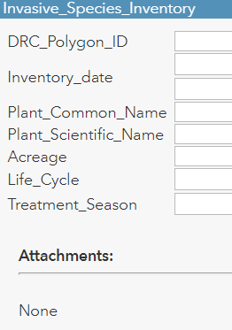

Figure 2. Invasive species inventory attribute table

## Passive Recruitment Assessment

The passive recruitment protocol adapted from the Dolores River Restoration Partnership (DRRP) will measure the naturally recruiting woody and herbaceous vegetation on all monitoring sites (i.e., vegetation occurring not from active re-vegetation.) In order for a site to show evidence of natural recruitment the site must meet at-least four of the following criteria:

1. At least 100 young coyote willow stems between 0.5 meters and 1 meter in height
2. At least 20 young cottonwoods, including plains and narrowleaf cottonwood species, that are greater than 1 meter in height with a diameter at breast height no greater than 10 cm
3. At least 20 young box elder maple trees that are greater than 1 meter in height with a diameter at breast height no greater than 10 cm
4. At least 20 individuals of New Mexico Privet that are young (2 – 10 stems at ground surface)
5. At least 20 individuals of Three-leaf Sumac that are young (2 – 10 stems at ground surface)
6. At least 20 individuals of Willow Baccharis that are young (2 – 10 stems at ground surface
7. Native understory herbaceous cover area 10 square feet or larger

Monitors collect a passive recruitment point and fill out an associated attribute table for each site. This information informs the whether the “Evidence_Natural_Recruitment” attribute in the Rapid Assessment is a “Yes” or “No.” Other information collected for passive recruitment includes presence of white crust on soil and evidence of bank erosion.

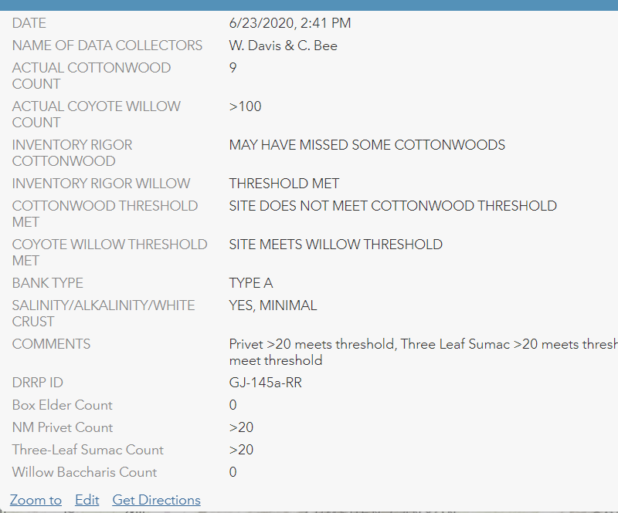

Figure 3. Passive Recruitment Attribute Table

## Data Collection Method

Monitors will assess passive recruitment on all sites where rapid monitoring is being performed, which includes sites that have undergone restoration activities or are planned for restoration. Monitoring is performed by a team of 2 people. Monitors will walk through the entirety of a site and count the species in the thresholds (coyote willow, cottonwoods, box elder, etc.) as they move through the site. If a threshold is reached for a species, monitors can stop counting that species and record >100, >20, etc. based on the threshold level for that species.

Monitors will collect passive recruitment data in Arc Collector by dropping a point within each site and filling out the associated data form. The data is then used to inform the Evidence of Passive Recruitment attribute in the Rapid Monitoring protocol. If a site meets one of the passive recruitment thresholds, then monitors mark “YES” for Evidence of Passive Recruitment. If no passive recruitment threshold is met, monitors mark “No” for Evidence of Passive Recruitment.

## Photo Points

For each site, at least two photo points will be established. The following guidelines will be followed:

Photo-points are taken for every monitored site every two-three years as part of rapid monitoring.

Monitors will use GIS enabled tablets with Arc Collector or Arc Field Maps. Photo-points are collected using a photo-point feature class with the following attributes:

* Date
* Names of Data Collectors
* Photo_Point_Name
* Datum
* Time
* Bearing
* Photo ID on Camera
* Comments
* GPS Accuracy
* DRC ID

Monitors drop a point at each photo-point, fill out the associated attribute table, and attach the photo to each point. Data is then synced from Collector/Field Maps to ArcOnline.

If photo-points already exist for a site, monitors should take another photo at that exact location and try to capture the same area in the photo.

Photos to be taken include:

* 1 Overview photo
* Taken from a high point or some vantage point that captures as much of the site as possible.
* 1-2 Photo points to capture future change – focus on treatment areas
  + Photos of areas where there is likely to be change in the next few years (i.e. fields of R knapweed that might get treated, a field of native grass seedlings, a cottonwood sapling that will grow larger, a bank filled with a bunch of new growth tamarisk, etc.) – think about what species may be treated.
* 1 Picture of an obvious treatment area
  + This can overlap with the “photo of change”
  + Typically, the photo will be of a tamarisk or Russian olive treatment area (stumps and possible re-sprouts) or a patch of tamarisk/Russian olive yet to be treated. Photo can also be of secondary weeds or Russian olive/Siberian Elm treatment if dominant treatment on-site.

Overall guidelines:

* There should be an **anchor in every photo** so that monitors have something to line up future photos with
  + Good anchors: Ridgelines, large boulders, canyon walls
  + Bad anchors: trees, vegetation, the river/riverbank (i.e., things that *change*)
* Think of future monitors – don’t make the points too hard to get to. (Not everyone is comfortable climbing boulders.)

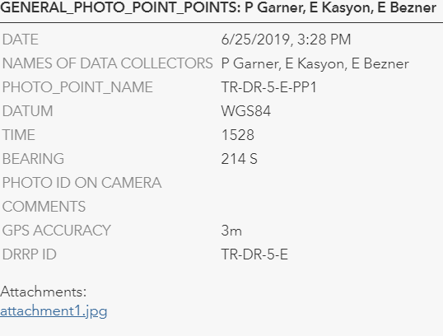

Figure 4. Phot points attribute table

# Training and Monitoring Intern recruitment:

RiversEdge West has procured grant funding from Colorado Water Conservation Board grant for two monitoring interns between May 31, 2021-August 2nd 2021. Western Colorado Conservation Corps is hiring the team and will provide the infrastructure and training for employment and be co-managed by RiversEdge West.

Training will be coordinated by RiversEdge West in conjunction with Conservation Legacy, Western Colorado Conservation Corps (WCCC), and Mesa County. The 2-person crew will receive chainsaw and herbicide training from WCCC and work with Mesa County’s Weed and Pest Coordinator on additional training and projects. RiversEdge West will train the team in plant identification, provide education on common restoration methods, and intensive training on the monitoring protocol.

About 85% of the intern’s time will be centered on monitoring sites along the Colorado, Gunnison, and other rivers in the Desert Rivers Collaborative area and on the Dolores River. It is estimated that two sites will be monitored each day. There is also an opportunity for the interns to work with partners on projects to gain experience in the area such as invasive species removal, herbicide application, active revegetation, trainings, monitoring and other needs.

Please work with Rica Fulton (rfulton@riversedgewest.org) if you have a project you would like help on in the time the interns will be employed.

# Sites to be monitored

Sites will be subsequently broken down into multiple monitoring polygons of under 20 acres based on the timing of past treatments, planned treatments, or other criteria as delineated by REW and land managers.

|  |  |
| --- | --- |
| **Site Name** | **Landowner** |
| Cameo | BOR |
| Island Acres Section – James M. Robb Co River State Park | CPW |
| Colorado River in Palisade near Hwy. 6 bridge | Palisade/CDOT |
| Riverbend Park | Palisade |
| Tillie Bishop SWA | CPW |
| 29 Rd. – Pear Park | CPW |
| Cottonwood HOA | HOA |
| Colorado River Wildlife Area | BOR |
| Las Colonias | City of GJ |
| Watson Island | City of GJ |
| Connected Lakes | CPW |
| Audubon River Preserve | Audubon Society |
| Walter Walker Wildlife Area | CPW |
| May Flats | BLM |
| Mee Canyon | BLM |
| Salt Wash – Fruita | City of Fruita |
| Little Salt Wash | City of Fruita |
| Dominguez Escalante NCA Sites - Gunnison River (Sand Flats) | BLM |
| Dominguez Escalante NCA Sites - Gunnison River (Leonards Basin) | BLM |
| Dominguez Escalante NCA Sites - Gunnison River (Leonards Basin ) | BLM |

# References

Cagney, J. (1993). *Greenline Riparian-wetland Monitoring: Riparian Area Management*. Retrieved from https://play.google.com/books/reader?id=-EVgRKgCbqYC&hl=en&pg=GBS.PP3

Coble, A. P., & Kolb, T. E. (2012). Riparian Tree Growth Response to Drought and Altered Streamflow along the Dolores River, Colorado. *Western Journal of Applied Forestry*, *27*(4), 205–211. doi: 10.5849/wjaf.12-001

Kasyon, E. 2021. Dolores River Restoration Partnership 2021 Rapid Monitoring Plan. Conservation Legacy.

G.L. Waring and L. E. Stevens, “The Effects of Recent Flooding on Riparian Plant Establishment in Grand Canyon,” in Glen Canyon Environmental Studies: Executive Summaries of Technical Reports. (1988). United States: U.S. Department of the Interior, [Bureau of Reclamation, Upper Colorado Regional Office].

Ottenbreit, K. A., & Staniforth, R. J. (1992). Life cycle and age structure of ramets in an expanding population of Salix exigua (sandbar willow). *Canadian Journal of Botany*, *70*(6), 1141–1146. doi: 10.1139/b92-141

Winward, A. H. (2000). *Monitoring the vegetation resources in riparian areas*. Retrieved from https://www.fs.fed.us/rm/pubs/rmrs_gtr047.pdf